# Exercises Unit 5.1 A. MANAGING DIRECTORIES

1.Change the current directory to /home/<user>:

We can just type **pwd.**

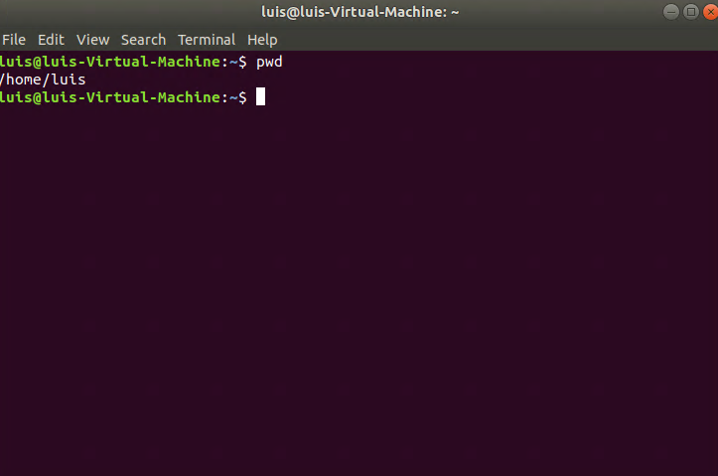

2.Create a directory called systems:

With: **mkdir (directory_name) : mkdir systems**

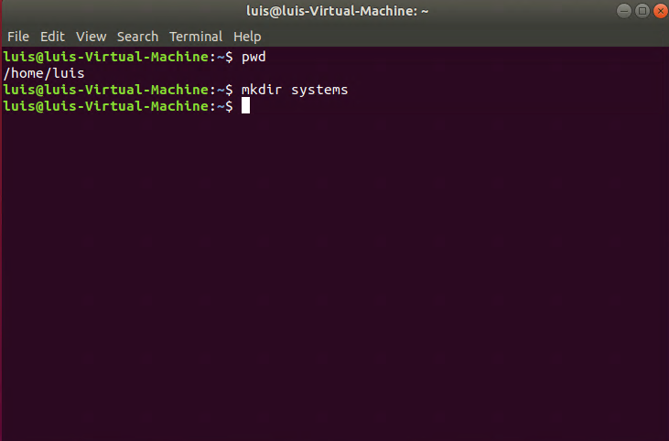

3.Create a directory called exercises. Go to this directory and create another new directory called programming.

We need to create the “exercises” directory by typing **mkdir exercises**, then **cd exercises** to acceses the directory and create inside exercises a new directory called programming with **mkdir programming.**

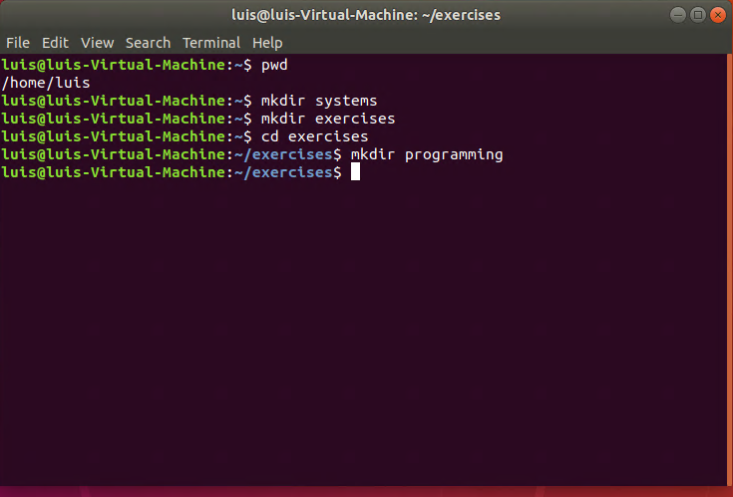

4.Go back to the user’s home directory. Delete the directories “exercises” and “programming” using just one command. Create the directories again with one command.

We will need to go to our HOME directory with **cd** comand and then type **rmdir -p exercises/programming**, which will delete both directories.

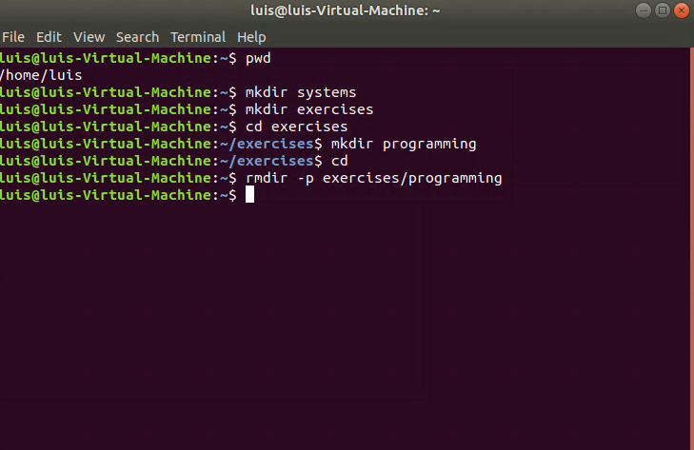

We will type **mkdir -p exercises/programming** to create both with this command.

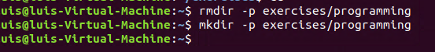

5.Print the contents of the root directory

To list all the files in the “root” directory, we will have to access it first. To do this, we will type **sudo su.** After that, located in the “root”, we will type **ls** to display the data.

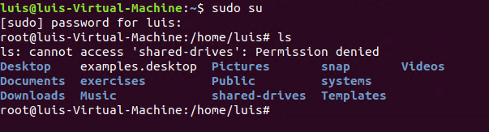

6.Print all the files and directories that begin withd in the /usr/bin directory

First we need to be located in this directory by typing **cd /usr/bin** . Then we will need to type **ls -d d*.**

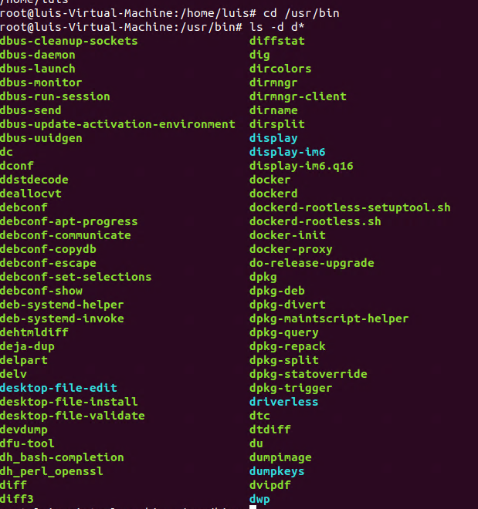

7.List all the files and directories in /etc, including subdirectories

l**s –R** and then add “/**etc**” so the command would be like this **ls -R /etc.**

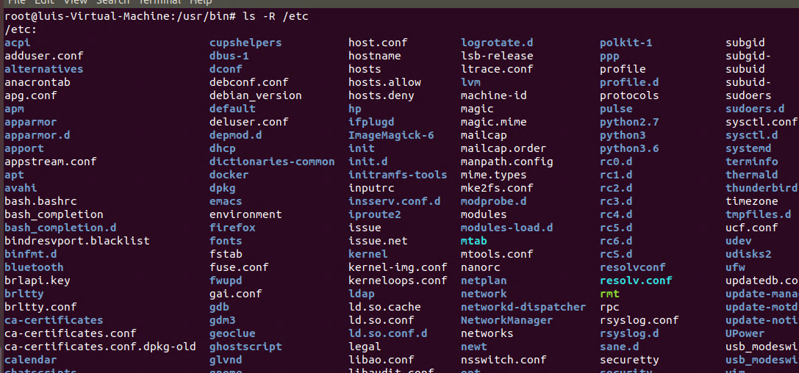

8.Create the empty files called student.txt, student1.txt, student2.txt, list, luggage and last in the directory named “systems”.

We need to type **cd systems** to locate inside it and then with **touch** to create the files. We will do it with 1 command: **touch student.txt student1.txt student2.txt list luggage last.**

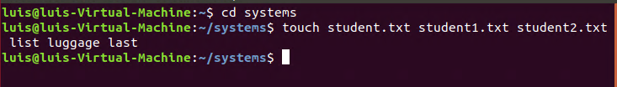

9.Print all the files that begin with “l” in the directory “systems”.

To list the files that start with “l” in “systems” we will have to type **ls -d l\***.

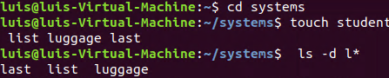

10.Print all the files that end with “txt” in the directory “systems”.

To list all the files that finish with “txt” in “systems” we will have to type **ls -d *txt**.



11.Create a new directory into $HOME called “config”.

To create a new directory in “home” we will have to go back with **cd ..** and creating the new one, called “config” **mkdir config**.

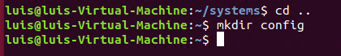

12.Copy all the files in /etc which begin with “a” into “config”.

**sudo cp -R /etc/a* /home/config** . The route will be diferente for each people.

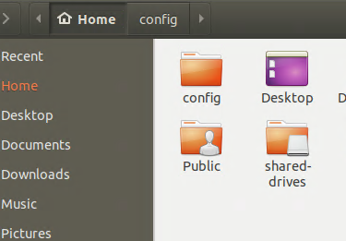

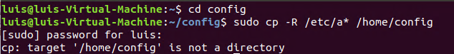

13.Delete all the files in “config” which end with “conf”.

**rm -i *conf**

